F O O D R U S H

Database Design Documentation
Food Delivery Management & Analytics System
SQL Capstone Project
MySQL · MySQL Workbench · Git / GitHub
Prepared as part of an intermediate-to-advanced SQL capstone project

Table of Contents
- 1. Introduction & Scope
- 2. System Modules
- 3. Entity Overview
- 4. Entity-Relationship Diagram (Textual)
- 5. Relationship Summary
- 6. Detailed Table Design (all 12 tables)
- 7. Keys & Referential Integrity Summary
- 8. Normalization (1NF, 2NF, 3NF)
- 9. Constraints Summary
- 10. Advanced Database Objects (Views, Procedures, Functions, Triggers, Events)
- 11. Design Decisions & Rationale
- 12. Conclusion

1. Introduction & Scope
FoodRush is a food delivery platform connecting customers, restaurants, delivery partners, and food items. This document defines the complete database design for FoodRush: every entity, its attributes, keys, constraints, and the relationships that connect them, along with the normalization reasoning behind the design and the advanced database objects (views, procedures, functions, triggers, events) built on top of the schema.
The design goal is a normalized relational schema (up to 3NF) that accurately reflects real-world food delivery operations — supporting customer management, restaurant and menu management, order processing, payments, delivery tracking, coupon management, and review/rating management — while remaining efficient to query for business analytics.
2. System Modules
- Customer Management
- Restaurant Management
- Menu Management
- Order Management
- Payment Management
- Delivery Management
- Coupon Management
- Review & Rating Management

3. Entity Overview
The schema consists of 12 tables, grouped by the module they primarily serve:
# | Table | Module | Purpose (one line)
1 | Customers | Customer Mgmt | Registered platform users who place orders
2 | Restaurants | Restaurant Mgmt | Partner restaurants listed on the platform
3 | Food_Categories | Menu Mgmt | Lookup table of food categories
4 | Menu_Items | Menu Mgmt | Food items offered by each restaurant
5 | Delivery_Partners | Delivery Mgmt | Riders who fulfill deliveries
6 | Orders | Order Mgmt | Core transactional order record
7 | Order_Items | Order Mgmt | Line items belonging to an order
8 | Payments | Payment Mgmt | Payment transactions against orders
9 | Deliveries | Delivery Mgmt | Delivery lifecycle tracking per order
10 | Coupons | Coupon Mgmt | Discount coupon definitions
11 | Order_Coupons | Coupon Mgmt | Coupons applied to specific orders
12 | Reviews | Review Mgmt | Customer ratings/feedback per order

4. Entity-Relationship Diagram (Textual)
The diagram below represents the relationship structure of the schema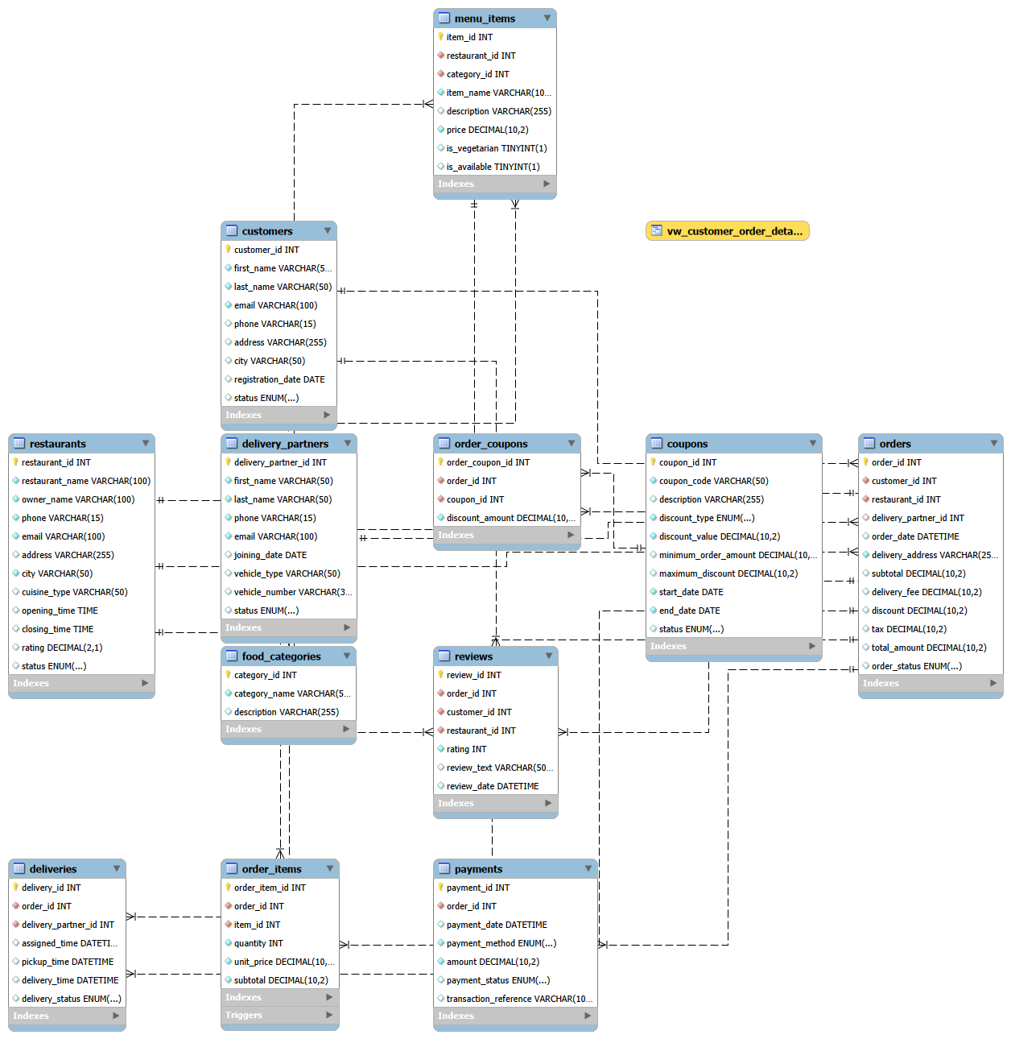

5. Relationship Summary

Parent Table | Child Table | Type | Foreign Key (in child)
Customers | Orders | 1 : N | Orders.customer_id
Restaurants | Orders | 1 : N | Orders.restaurant_id
Delivery_Partners | Orders | 1 : N (nullable) | Orders.delivery_partner_id
Restaurants | Menu_Items | 1 : N | Menu_Items.restaurant_id
Food_Categories | Menu_Items | 1 : N | Menu_Items.category_id
Orders | Order_Items | 1 : N | Order_Items.order_id
Menu_Items | Order_Items | 1 : N | Order_Items.item_id
Orders | Payments | 1 : N* | Payments.order_id
Orders | Deliveries | 1 : 1 | Deliveries.order_id (UNIQUE)
Delivery_Partners | Deliveries | 1 : N | Deliveries.delivery_partner_id
Orders | Order_Coupons | 1 : N | Order_Coupons.order_id
Coupons | Order_Coupons | 1 : N | Order_Coupons.coupon_id
Orders | Reviews | 1 : N | Reviews.order_id
Customers | Reviews | 1 : N | Reviews.customer_id
Restaurants | Reviews | 1 : N | Reviews.restaurant_id

6. Detailed Table Design
6.1 Customers
Stores registered customer details.
Column | Data Type | Key | Constraints / Notes
customer_id | INT | PK | AUTO_INCREMENT
first_name | VARCHAR(50) |  | NOT NULL
last_name | VARCHAR(50) |  | NOT NULL
email | VARCHAR(100) |  | NOT NULL, UNIQUE
phone | VARCHAR(15) |  | NOT NULL, UNIQUE
address | VARCHAR(255)
city | VARCHAR(50) |  | NOT NULL
registration_date | DATE |  | NOT NULL, DEFAULT CURRENT_DATE
status | ENUM |  | 'Active','Inactive','Blocked'; DEFAULT 'Active'
6.2 Restaurants
Stores partner restaurant profile details.
Column | Data Type | Key | Constraints / Notes
restaurant_id | INT | PK | AUTO_INCREMENT
restaurant_name | VARCHAR(100) |  | NOT NULL
owner_name | VARCHAR(100) |  | NOT NULL
phone | VARCHAR(15) |  | NOT NULL, UNIQUE
email | VARCHAR(100) |  | UNIQUE
address | VARCHAR(255) |  | NOT NULL
city | VARCHAR(50) |  | NOT NULL
cuisine_type | VARCHAR(50)
opening_time | TIME |  | NOT NULL
closing_time | TIME |  | NOT NULL
rating | DECIMAL(2,1) |  | CHECK (0–5), DEFAULT 0.0
status | ENUM |  | 'Active','Inactive','Closed'; DEFAULT 'Active'
6.3 Food_Categories
Lookup table of food categories used to classify menu items.
Column | Data Type | Key | Constraints / Notes
category_id | INT | PK | AUTO_INCREMENT
category_name | VARCHAR(50) |  | NOT NULL, UNIQUE
description | VARCHAR(255)
6.4 Menu_Items
Food items offered by a specific restaurant.
Column | Data Type | Key | Constraints / Notes
item_id | INT | PK | AUTO_INCREMENT
restaurant_id | INT | FK | → Restaurants.restaurant_id, NOT NULL, ON DELETE CASCADE
category_id | INT | FK | → Food_Categories.category_id, NOT NULL, ON DELETE RESTRICT
item_name | VARCHAR(100) |  | NOT NULL
description | VARCHAR(255)
price | DECIMAL(8,2) |  | NOT NULL, CHECK (price > 0)
is_vegetarian | BOOLEAN |  | NOT NULL, DEFAULT TRUE
is_available | BOOLEAN |  | NOT NULL, DEFAULT TRUE
6.5 Delivery_Partners
Delivery staff details and current availability.
Column | Data Type | Key | Constraints / Notes
delivery_partner_id | INT | PK | AUTO_INCREMENT
first_name | VARCHAR(50) |  | NOT NULL
last_name | VARCHAR(50) |  | NOT NULL
phone | VARCHAR(15) |  | NOT NULL, UNIQUE
email | VARCHAR(100) |  | UNIQUE
joining_date | DATE |  | NOT NULL, DEFAULT CURRENT_DATE
vehicle_type | ENUM |  | 'Bike','Scooter','Bicycle','Car'
vehicle_number | VARCHAR(20)
status | ENUM |  | 'Available','Busy','Offline','Inactive'; DEFAULT 'Offline'

6.6 Orders
The central transactional table — one row per customer order.
Column | Data Type | Key | Constraints / Notes
order_id | INT | PK | AUTO_INCREMENT
customer_id | INT | FK | → Customers.customer_id, NOT NULL, ON DELETE RESTRICT
restaurant_id | INT | FK | → Restaurants.restaurant_id, NOT NULL, ON DELETE RESTRICT
delivery_partner_id | INT | FK | → Delivery_Partners.delivery_partner_id, NULLABLE, ON DELETE SET NULL
order_date | DATETIME |  | NOT NULL, DEFAULT CURRENT_TIMESTAMP
delivery_address | VARCHAR(255) |  | NOT NULL
subtotal | DECIMAL(10,2) |  | NOT NULL, DEFAULT 0.00
delivery_fee | DECIMAL(8,2) |  | NOT NULL, DEFAULT 0.00
discount | DECIMAL(8,2) |  | NOT NULL, DEFAULT 0.00
tax | DECIMAL(8,2) |  | NOT NULL, DEFAULT 0.00
total_amount | DECIMAL(10,2) |  | NOT NULL, DEFAULT 0.00
order_status | ENUM |  | 'Placed','Confirmed','Preparing','Out for Delivery','Delivered','Cancelled','Rejected'
6.7 Order_Items
Bridge table resolving the many-to-many relationship between Orders and Menu_Items.
Column | Data Type | Key | Constraints / Notes
order_item_id | INT | PK | AUTO_INCREMENT
order_id | INT | FK | → Orders.order_id, NOT NULL, ON DELETE CASCADE
item_id | INT | FK | → Menu_Items.item_id, NOT NULL, ON DELETE RESTRICT
quantity | INT |  | NOT NULL, CHECK (quantity > 0)
unit_price | DECIMAL(8,2) |  | NOT NULL
subtotal | DECIMAL(10,2) |  | NOT NULL

6.8 Payments
Payment transaction record for an order.
Column | Data Type | Key | Constraints / Notes
payment_id | INT | PK | AUTO_INCREMENT
order_id | INT | FK | → Orders.order_id, NOT NULL, ON DELETE CASCADE
payment_date | DATETIME |  | NOT NULL, DEFAULT CURRENT_TIMESTAMP
payment_method | ENUM |  | 'UPI','Credit Card','Debit Card','Cash','Wallet','Net Banking'
amount | DECIMAL(10,2) |  | NOT NULL
payment_status | ENUM |  | 'Successful','Pending','Failed','Refunded'; DEFAULT 'Pending'
transaction_reference | VARCHAR(100) |  | UNIQUE
6.9 Deliveries
Tracks the delivery lifecycle for each order.
Column | Data Type | Key | Constraints / Notes
delivery_id | INT | PK | AUTO_INCREMENT
order_id | INT | FK, UNIQUE | → Orders.order_id, NOT NULL, ON DELETE CASCADE
delivery_partner_id | INT | FK | → Delivery_Partners.delivery_partner_id, NULLABLE, ON DELETE SET NULL
assigned_time | DATETIME
pickup_time | DATETIME
delivery_time | DATETIME
delivery_status | ENUM |  | 'Assigned','Picked Up','Delivered','Failed','Cancelled'
6.10 Coupons
Discount coupon definitions, independent of any single order.
Column | Data Type | Key | Constraints / Notes
coupon_id | INT | PK | AUTO_INCREMENT
coupon_code | VARCHAR(30) |  | NOT NULL, UNIQUE
description | VARCHAR(255)
discount_type | ENUM |  | 'Percentage','Flat'
discount_value | DECIMAL(8,2) |  | NOT NULL, CHECK (discount_value > 0)
minimum_order_amount | DECIMAL(8,2) |  | DEFAULT 0.00
maximum_discount | DECIMAL(8,2)
start_date | DATE |  | NOT NULL
end_date | DATE |  | NOT NULL, CHECK (end_date >= start_date)
status | ENUM |  | 'Active','Inactive','Expired'; DEFAULT 'Active'
6.11 Order_Coupons
Bridge table resolving the many-to-many relationship between Orders and Coupons.
Column | Data Type | Key | Constraints / Notes
order_coupon_id | INT | PK | AUTO_INCREMENT
order_id | INT | FK | → Orders.order_id, NOT NULL, ON DELETE CASCADE
coupon_id | INT | FK | → Coupons.coupon_id, NOT NULL, ON DELETE RESTRICT
discount_amount | DECIMAL(8,2) |  | NOT NULL
UNIQUE (order_id, coupon_id) — ensures the same coupon cannot be applied twice to one order.
6.12 Reviews
Customer ratings and feedback tied to a specific order.
Column | Data Type | Key | Constraints / Notes
review_id | INT | PK | AUTO_INCREMENT
order_id | INT | FK | → Orders.order_id, NOT NULL, ON DELETE CASCADE
customer_id | INT | FK | → Customers.customer_id, NOT NULL, ON DELETE CASCADE
restaurant_id | INT | FK | → Restaurants.restaurant_id, NOT NULL, ON DELETE CASCADE
rating | TINYINT |  | NOT NULL, CHECK (rating BETWEEN 1 AND 5)
review_text | VARCHAR(500)
review_date | DATETIME |  | NOT NULL, DEFAULT CURRENT_TIMESTAMP

7. Keys & Referential Integrity Summary
Primary Keys
Every table uses a single-column surrogate primary key (an auto-incrementing integer ID) rather than a natural/composite key. This keeps joins simple and fast, and insulates the schema from changes to naturally-unique-seeming values (e.g., email or phone) which could theoretically change or be reused.
Foreign Key Delete Rules
Rule | Used On | Reasoning
CASCADE | Menu_Items→Restaurants, Order_Items→Orders, Payments→Orders, Deliveries→Orders, Order_Coupons→Orders, Reviews→Orders/Customers/Restaurants | If the parent (e.g., an Order) is deleted, its dependent child records (items, payment, delivery, review) no longer make sense on their own and should be removed together.
RESTRICT | Orders→Customers, Orders→Restaurants, Order_Items→Menu_Items, Order_Coupons→Coupons | Prevents deleting a Customer/Restaurant/Menu Item/Coupon that still has historical orders referencing it — protects transactional history from being silently destroyed.
SET NULL | Orders→Delivery_Partners, Deliveries→Delivery_Partners | If a delivery partner record is removed (e.g., they leave the company), past orders/deliveries should remain, just without a valid partner reference, rather than being deleted or blocked.

8. Normalization
1NF — First Normal Form
Requirement: atomic values, no repeating groups, each column holds a single value.
Applied: Food items within an order are never stored as a comma-separated list inside Orders — they are split into individual rows in Order_Items, one row per item per order. Every column across all 12 tables holds a single atomic value (e.g., no combined 'name' field holding both first and last name).
2NF — Second Normal Form
Requirement: already in 1NF, and every non-key column depends on the whole primary key, not just part of it.
Applied: this rule matters most for tables that conceptually represent a combination of two other entities, like Order_Items. Although Order_Items uses a single surrogate key (order_item_id) rather than a composite key of (order_id, item_id), the non-key columns quantity, unit_price, and subtotal are still logically dependent on the full combination of order and item — not on order_id alone (different items in the same order have different quantities/prices) and not on item_id alone (the same item can appear in many orders with different quantities).
3NF — Third Normal Form
Requirement: already in 2NF, and no transitive dependencies — non-key columns depend only on the primary key, not on other non-key columns.
Applied: Orders does not store restaurant_city, restaurant_name, or customer_name directly — these are transitively dependent on restaurant_id and customer_id respectively, which are already stored as foreign keys. Storing them redundantly in Orders would mean that changing a restaurant's city would require updating every historical order row referencing that restaurant, and would risk the columns becoming inconsistent over time. Instead, this data is retrieved via a JOIN when needed.

9. Constraints Summary
Constraint Type | Example | Purpose
NOT NULL | Customers.email, Orders.customer_id | Ensures mandatory business data is always captured
UNIQUE | Customers.email, Coupons.coupon_code | Prevents duplicate accounts / duplicate coupon codes
CHECK | Reviews.rating BETWEEN 1 AND 5 | Enforces valid value ranges at the database level, independent of application code
DEFAULT | Orders.order_status = 'Placed' | Provides sensible starting values without requiring the application to set every column explicitly
FOREIGN KEY | Orders.customer_id → Customers.customer_id | Enforces referential integrity — an order can never reference a customer that doesn't exist
ENUM | Orders.order_status, Payments.payment_method | Restricts a column to a fixed, known set of valid business states
10. Advanced Database Objects
Views
vw_customer_order_details — Customer + order + restaurant join for quick order lookups.
vw_restaurant_performance — Per-restaurant totals: orders, revenue, avg order value, rating.
vw_delivery_partner_performance — Per-partner totals: deliveries, avg delivery time, avg rating.
Stored Procedures
sp_place_order — Creates an order + order item in one transaction; returns the new order_id via an OUT parameter.
sp_customer_spending_report — Given a customer_id, returns a full spending summary and segment classification.
Functions
fn_calculate_delivery_charge — Tiered distance-based delivery fee calculator.
fn_customer_segment — Classifies a spending amount into Low / Medium / High Value.
Triggers
trg_update_order_total_after_insert — Keeps Orders.subtotal/total_amount in sync after Order_Items changes.
trg_update_order_status_after_payment — Auto-confirms an order once its payment succeeds.
trg_validate_review_rating — Blocks review inserts with an out-of-range rating, with a custom error message.
Events
ev_expire_coupons — Daily job that marks expired coupons Inactive.
ev_daily_sales_summary — Daily job that writes yesterday's order/revenue totals into a summary table.

12. Conclusion
The FoodRush schema is normalized to 3NF, uses surrogate primary keys with consistent foreign-key delete semantics, and separates concerns across 12 focused tables rather than a small number of overloaded ones. Every table, relationship, and constraint in this design maps directly to a real operational need in a food delivery business, rather than existing purely to satisfy a checklist — which is the core design philosophy behind this project.

